Graphs Used In Core Country Reports

Introduction
This document contains a ‘core’ set of graphs used in most country reports. It was initially created by the WB side. It is intended to inform a) a user guide for WB country reports and b) the next iteration of a simplification of CPAT. The scope include CBAM and TCP (WB only)

Core Graphs
TCP
- Existing prices, taxes and subsidies (table)
- TCP in time
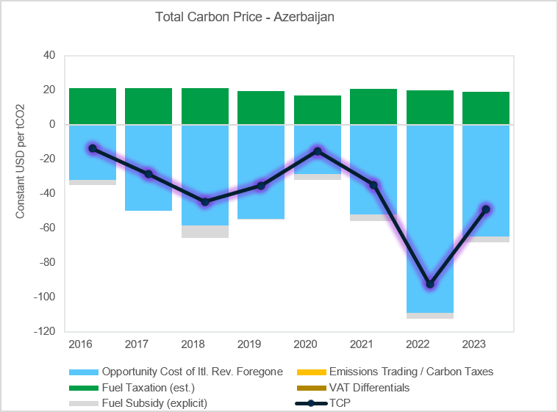
Scenario Definition
- Price of fuels, baseline and policy scenario (one graph for coal, nat. gas, gasoline and diesel) ++ (do four new graphs)

- Carbon-price trajectory (separate line for ETS price)+(Integrate with TCP?)
Mitigation:
- Emissions: Absolute GHG emissions and NDC (all gases/sources)*

- Revenues: Projected additional revenues from fossil-fuel-subsidy phase-out and carbon-tax reforms

- GDP: Impacts on real GDP growth by scenario – percentage points relative to BAU

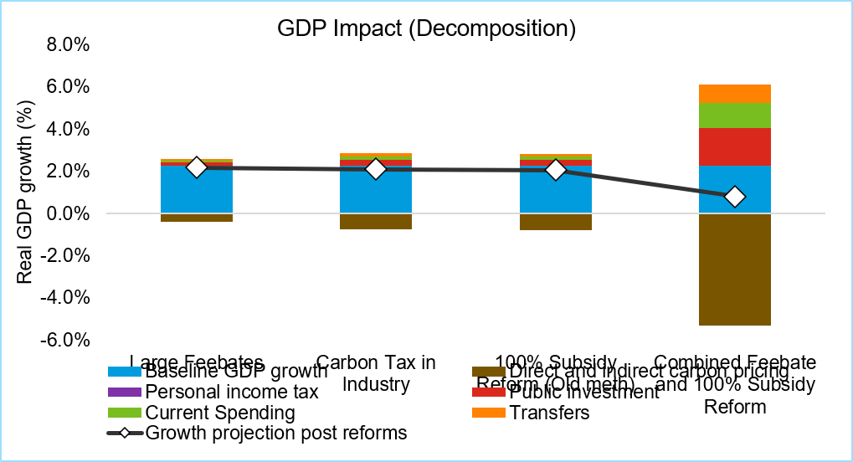
Distribution Module:
- Incidence: Mean household incidence after revenue recycling, by effect type (as % of household consumption) (one per scenario)

Air Pollution
- Deaths: Deaths from improved air quality and reduced road accidents +(change to non-cumulative??)

- GDP-Equivalent: Net national welfare co-benefits by component (as % of GDP)

Advanced Graphs
TCP:
- TCP by component
- TCP relative to peers
Mitigation:
- Externalities by fuel/sector
- Existing prices by fuel/sector versus total social cost
Mitigation:
- Absolute emissions change
- Additional fiscal revenues net of subsidies, by fuel
- GDP growth projections
- Impacts on real GDP growth by scenario – Real GDP Growth Impact Decomposition
Distribution Module:
- Mean household incidence before revenue recycling
- Mean household incidence after revenue recycling
- Mean household incidence before revenue recycling, by effect type and welfare decile (as % of household consumption, by scenario)
- Impact on the Gini coefficient for consumption, pre- vs. post-revenue recycling

